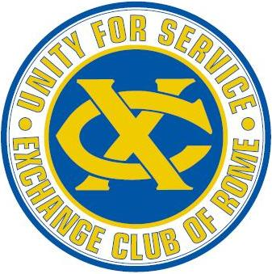
Exchange Club of Rome
Business Meeting Minutes
June 14, 2019

- Call to Order 12:00 – Put out the Blue Cups

- Invocation: Tina Bartleson

- Pledge of Allegiance: Bob Evans

- Mute phones $10

- Birthdays – Today , Bryan Shealy

- Fellowship – Steve White: Charles Stevens Father in-law passed away. Adrian Fanjoy-Marine passed away. Prayers for Ralph White. Former member Heywood Patton had a stent put in and doing well.

- Minutes & Correspondence – Robert Smyth – Minutes of the May business meeting have been posted. One Correspondence from Cara Clements. See attached file. Brian Shealy moved the minutes be accepted. Steve White 2nd. Approved.

- Treasurer’s Report – Buzz Wachsteter See Attached. National Convention Travel Expenses paid. Other Expenses will be paid when arrive. Star Spangled Flag replacement paid for. Charles Norris thanked Buzz for a great job.

- Membership:
- Beginning membership – 209
- Resignations – none
- Drops – none
- Inductions – 1 – John Caldwell who is being sponsored by Lee Hamby (Buzz did the induction).
- Ending Membership – 210
- YTD Growth Rate = 3.0% / YTD Retention Rate = 91.8%
- New App’s = 3: Applications Attached.
- Andrea Pitts / Wanda Whitten
- Joyce Johnson / Stacey Walker
- Walter Bunte / Larry Walker

- Standing Committee Reports: Your committee Chairs have worked extremely hard all year. Some you see what they are up to regularly like the Americanism but others are working quietly behind the scenes. After each Committee Chair addresses the membership, I ask you to please show them your appreciation with a round of applause. Committee Chairs I will ask when you address the membership at this last business meeting, please take the mic.
- Americanism – John Fortune 43 POS’s, 30,000 people touched, 20 Exchangites participated and 91 volunteers all worked with Americanism and the Tomb. See the Newsletter for the Tomb appearance schedule.
- Awards – Carol Abrams – All awards finished and turned in. Carol also made a club scrap book. Charles Norris presented Awards from District Convention.
- New Member Expansion & Retention – Carol Abrams Shirts are in stock if needed.
- Cap & FRC – Larry Walker & Tina Bartleson. Please remember to give to the FRC. Would like to see higher club participation. Special Thank you from President Charles Norris for great year. Tina reported the FRC has been invited back to Back to school bash at Rome Hi. Thank you to Larry Walker for all his efforts this year.
- Community Service – George Fricks: Thanks to DR. Mike Jackson for efforts with habitat build. The build will be completed in July. He will taking over as Community Service Committee Chair. Backpacks for Sheriff’s office being put together.
- Programs – Patrick Eidson. See the Newsletter for program schedule. June 21st Installation Dinner, 22nd Board Retreat.
- Social – Charles Norris. – Installation dinner June 21^{st, .}Reception at 6, Dinner at 6:30. / 50/50 raffle (Linda Hatcher) / JP Cooper & Bryan Shealy = bar / Gail Johnson & Barbara Carter will check folks in. $25 = cost for additional guest. National President Tracey Edwards will be in attendance.
- Youth – Frank Shropshire: No Report. New Chari will be Diane Warner
- Toys for Tots – Linda Hatcher: All is good, 38,000.00 left over so far. Will need help cleaning up area for toys.

- Old / New Business: Registration has been re-opened for Instillation dinner until Monday the 17th. Please use front gate for dinner.

- Adjourn

